Minden Gardnerville Sanitation manager wins top honors
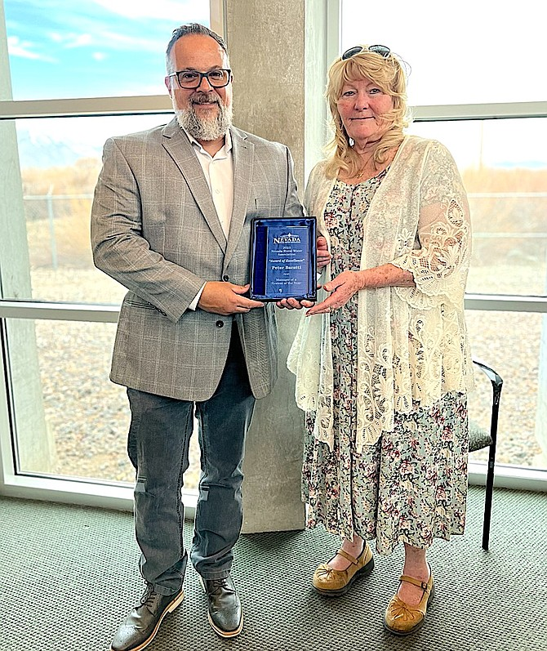
Minden Gardnerville Sanitation District Manager Peter Baratti and Chairwoman Barbara Smallwood.
Staff Reports
Friday, April 21, 2023
- DiscussComment, Blog about
- Share thisEmail, Facebook, Twitter
Minden Gardnerville Sanitation District Manager Peter Baratti was named 2023 System Manager of the Year by the Nevada Rural Water Association.
Each year, the association presents awards in various categories to employees of member systems that have done an outstanding job in the water and wastewater fields.
Baratti came to work for the district in 2011 as an operator-in-training and became the treatment plant’s operations supervisor in 2017. In 2019, district trustees appointed Baratti to district manager.
“The Board of Trustees, staff and customers appreciate Peter’s involvement with MGSD, and everything he does to go to the next level, both with MGSD and with everything he has done in the community,” said District Chairwoman Barbara Smallwood. “Mr. Baratti has worked to be proactive in rehabilitating and replacing the district’s equipment and has created positive interactions with other agencies and in the community, improving the district’s input with regional growth and development.”
Baratti said the district staff has benefited from the support and training provided by the association.
“They are a great group of people who offer a lot of aid to small water and wastewater utilities in Nevada,” he said. “I am honored to have been acknowledged by such an organization as theirs.”
The district has provided sewer service within the towns of Minden and Gardnerville since 1965.

